REPORT

DATA COLLECTION, CLEANING AND PREPROCESSING
California Housing Dataset

1. Data Collection Method
The analysis begins by reading a comma-separated values (CSV) file named housing.csv using pandas. The CSV file is treated as the source dataset and loaded into a pandas DataFrame. This approach is simple, reproducible, and appropriate for a tabular machine-learning workflow.
Collection/loading code:
import pandas as pd
data = pd.read_csv('housing.csv')
print(data.shape)
print(data.head())
print(data.describe())
print(data.info())
2. Initial Data Inspection
Before modifying the data, the workflow performs basic inspection. shape determines the number of rows and columns, head() previews records, describe() provides descriptive statistics for numerical columns, and info() reveals data types and missing-value counts.
This stage is important because preprocessing decisions should be based on the actual structure and quality of the dataset rather than assumptions.
Inspection code:
print(data.shape)
print(data.head())
print(data.describe())
print(data.info())
3. Data Cleaning Procedures
Duplicate Record Check
The workflow checks for completely duplicated rows using duplicated(keep=False). Keeping all duplicated occurrences makes it possible to inspect every record belonging to a duplicate group.
print(data[data.duplicated(keep=False)])
A useful distinction is that duplicate detection should normally be performed across the full row unless there is a documented business key. The commented longitude-only check in the original code is not a reliable duplicate test because many different households can legitimately share the same longitude.
Target Variable Inspection
The median_house_value variable is visualized using a boxplot, and its minimum and maximum values are inspected. This helps identify extreme values and understand the target range before modeling.
plt.boxplot(data['median_house_value'])
print(min(data['median_house_value']), max(data['median_house_value']))
plt.show()
Handling Missing Values
The initial inspection identifies missing values in total_bedrooms. The workflow calculates the median of this column and replaces missing entries with that median.
median_bedrooms = data['total_bedrooms'].median()
data['total_bedrooms'] = data['total_bedrooms'].fillna(median_bedrooms)
Median imputation is appropriate here because it is less sensitive to extreme values than mean imputation. It also preserves the number of observations.
4. Feature Engineering
Feature engineering transforms the original variables into representations that may be more informative for a machine-learning model.

Old-Housing Indicator
A binary feature named is_old is created. A value of 1 indicates a housing median age of at least 50 years; otherwise the value is 0.
data['is_old'] = (data['housing_median_age'] >= 50).astype(int)
print(data['is_old'].value_counts())

Ratio-Based Features
Three ratio features are generated to capture household composition and density more directly:
data["rooms_per_household"] = data["total_rooms"] / data["households"]
data["bedrooms_per_room"] = data["total_bedrooms"] / data["total_rooms"]
data["population_per_household"] = data["population"] / data["households"]
5. Log Transformation of Skewed Features
Several count-like variables can be heavily right-skewed. The workflow applies np.log1p(), which computes log(1 + x), to total_rooms, total_bedrooms, population, and households. The +1 component allows zero values to be transformed safely.
skewed_features = ['total_rooms', 'total_bedrooms', 'population', 'households']
for feature in skewed_features:
data[feature + '_log'] = np.log1p(data[feature])
data = data.drop(columns=skewed_features)
The original raw columns are subsequently removed to reduce redundancy. This decision should be validated experimentally because some models may benefit from retaining both raw and transformed versions.

6. Numerical Feature Scaling
The selected numerical variables are standardized using StandardScaler. Standardization subtracts the feature mean and divides by its standard deviation, producing features on approximately comparable scales.
numerical_features = [
'longitude', 'latitude', 'housing_median_age', 'median_income',
'total_rooms_log', 'total_bedrooms_log', 'population_log',
'households_log', 'rooms_per_household', 'bedrooms_per_room',
'population_per_household'
]
scaler = StandardScaler()
data[numerical_features] = scaler.fit_transform(data[numerical_features])
Scaling is particularly useful for distance-based, gradient-based, and regularized models.
7. Categorical Encoding
The ocean_proximity column is categorical and therefore must be converted to numerical features for most machine-learning algorithms. OneHotEncoder creates a separate indicator column for each category. drop='first' removes the first category and avoids perfect multicollinearity when an intercept-based model is used.
encoder = OneHotEncoder(sparse_output=False, drop='first')
housing_cat = data[["ocean_proximity"]]
encoded = encoder.fit_transform(housing_cat)
encoded_df = pd.DataFrame(
encoded,
columns=encoder.get_feature_names_out()
)
data = pd.concat(
[data.drop('ocean_proximity', axis=1), encoded_df],
axis=1
)

8. Challenges Faced and How They Were Overcome
Missing values: total_bedrooms contains null values. Median imputation was used to preserve observations while reducing sensitivity to outliers.
Duplicate detection: A full-row duplicate check was used. Checking only longitude would incorrectly classify legitimate records as duplicates.
Skewed distributions: Log1p transformations were applied to selected count variables to reduce the influence of long right tails.
Categorical variables: ocean_proximity was transformed using one-hot encoding so it could be used numerically by machine-learning algorithms.
Different numerical scales: StandardScaler was applied so selected numerical features have comparable scale.
Feature redundancy: Original versions of log-transformed variables were removed after transformation.
Artificial Data Caps: The 'median_house_value' and 'housing_median_age' metrics were capped at $500,001 and 52 years, respectively. These hard limits created massive spikes in the data distribution, which could heavily skew regression models.
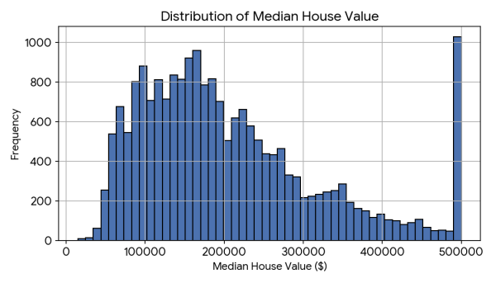

12. Conclusion
The supplied workflow provides a solid foundation for preparing the California housing data for machine learning. It addresses major data-quality and representation issues through inspection, missing-value treatment, feature engineering, transformation, scaling, and categorical encoding. The resulting dataset is substantially more suitable for modeling than the raw CSV.

